# 

| When You Arrive: |
| --- |
| * Find the schedule and sign in under your shift date * Add cheese to the nacho machine and use the “Nacho” guide posted next to the machine for more detailed instructions * Turn on nacho machine * Saturdays Only: Prepare chili, use “Chili” guide for more detailed instruction * Turn on the hot dog roller using the red switch on the front Set the temperature to medium Use “Hot Dog” guide posted on the wall near the roller for more detailed instructions * Turn on the food warmer located next to the hot dog roller Make sure there is water in the food warmer * Get the bucket from on top of the soda fountain to get ice from the “breezeway” Remove lids from the soda machine and pour in the ice Fill with 3-4 buckets of ice Close lid and return bucket to top of the soda machine * Wash Air Fryer bins if they were not washed the night before * Stock your Candy/Snack displays if they are stocked. * Complete “Outside Setup” instructions * Set up your condiment table outside Use the “Condiment” instructions * Make sure the ipad and cash box are ready Use the “Taking Order and Taking Payment” guide for more detailed instructions |

| During Your Shift: |
| --- |
| * make sure items are stocked * refill sauce cups * check condiment table for refill and any necessary cleaning * wipe surface areas as needed |

| Closing Instructions: |
| --- |
| * Bring in the condiments and table * Bring in chip and candy displays * Close roll up door and lock (make sure to pull up on door to ensure it is locked) * Close windows * Place air fryer bins to soak in the sink with soap water and wash before ending your shift. * Turn off Nacho Machine, and take out any opened cheese and place in the refrigerator * Turn off the crockpot and throw out any remaining chili. If no liner was used, place the dirty crock pot in the sink to soak with soap water. Wash before the end of your shift. * Turn off hot dog roller, wipe down around roller and cover rollers with foil sheets * Turn off and unplug food warmer Please take out any unsold hot dogs out of the food warmer * Once everything is is cleared, wiped down surface areas with a clorox wipe * Please do a light sweep of the snack bar, brooms are located next to the soda machine * Place batteries from small scoreboard controllers to charge on the power strip next to the hot drink area * Place walkie talkies to charge * Place ipad and square to charge * Take out the trash to one of the outside garbage cans and replace with a new bag * Board Member on Duty will lock up any cash and will lock up the snack bar |

# 

| Outside Setup: |
| --- |
| * Open the front windows, far left window will be used for food pick up and the far right will be used to take orders * Unlock the rollup door, turn the key until you hear it “unlock” * Pull the roll up door up, and then you can roll it all the way from the outside * Place the candy/snack bin between the “Order Here” and “Pick Up Here” Window * Set up the menu/sandwich board outside |

| **Ipad Operation: Taking Orders and Taking Payment** |
| --- |
| **Person at this station must be 18 or older** |
| * Open the cash box and ensure there is enough change to start the day If not, please notify the Board Member on Duty * Turn on iPad and card reader   + iPad code is posted in the snack bar * Check “settings” to make sure the Cellular Data is turned onIcon    Description automatically generated * Open the SQUARE app (on the bottomtray of icons)   + Once the app is open, go to “CHECKOUT” on the bottom,   + Select “2025 Spring Season”     - Each button will ring the appropriate amount     - Tap twice if multiple items of the same type are ordered   + When the customer is done ordering, select “CHECK OUT”     - Review the order Ensure all items are add and the correct amounts of each item   + After reviewing the order, select “CHARGE”     - Cash and Card payment is accepted:       * CARD PAYMENT: using the square reader, it is a tap to pay, and a chip reader It should automatically finish the transaction once the customer taps or inserts their card       * CASH PAYMENTS: Please tap the first dollar amount option, which should be the full dollar amount of the transaction. This will finish the transaction. Give customer their change if needed |
| **How To Ring Out Umpire Meals:**   * Umpires will get one meal per game they work * Meal options are a drink and one choice from the following menu:   + Hot Dog   + Nachos   + Mozzarella Sticks   + Chicken Nuggets * Choose the menu item title “Umpire Meal” * Please take the umpire’s name and check their name off on the umpire schedule to indicate that they picked up their meal |

| Condiment Table Setup: |
| --- |
| * Set up the skinny table (located on the left side of the Large fridge) outside, to the right of the windows * Place napkin dispensers, ketchup, mustard, relish, creamer, sugar, stir sticks and straws on the table |

| Fountain Soda: |
| --- |
| * Go into the breezeway, and load three buckets of ice into the top of the soda machine with the bucket located on top of the ice machine * Replace the lid, and ensure that ice dispenses   + If there is a blockage, use the ice scoop to break up the ice, while running the dispenser * We honor any other league tumblers just charge the Tumbler Refill ($1) |

# 

| **Nachos:** |
| --- |
| * Take Cheese bag from the refrigerator and install it into nacho machine (See instructions below) * Turn on the cheese warmer There is a switch in the back, and the plug is along the wall * Make sure you have chips open and ready, and that you are stocked on paper trays for serving * Jalapenos- prefill in portion cups with lids and store in the small fridge Served upon request |

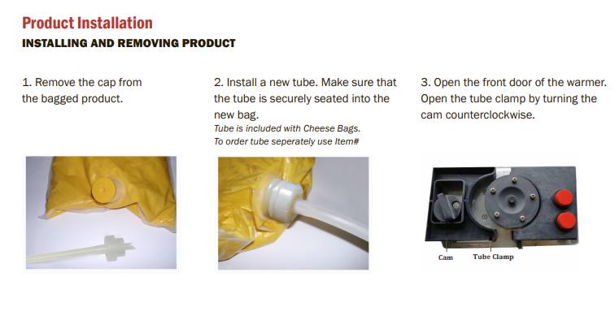

**PLEASE USE A NEW TUBE WITH EVERY NEW BAG**

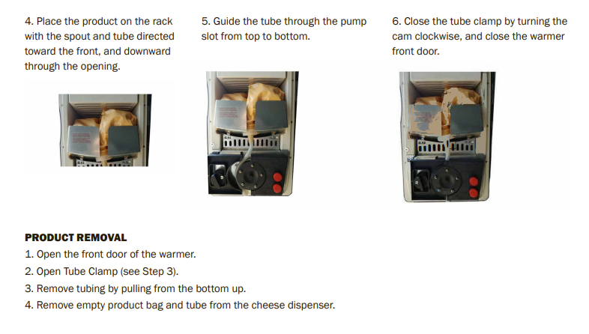

| **Chili: ONLY AVAILABLE ON SATURDAYS** |
| --- |
| * Use crock pot liner * Pour chili into crock pot and turn on high (open new can or use chili from the refrigerator)   + For Saturday, use a full can   + Chili is optional on weekdays & Sundays: If made please use half of a can and store the remainder in one of the small plastic containers with a lid Put the container in the refrigerator * Chili Dogs and Chili Cheese Nachos are each one spoonful of chili each |

| **Mozzarella Sticks: 6 Per Order** |
| --- |
| * Set one bag, located in large white freezer, in the food warmer (metal steamer next to the hot dog roller)Use this to help prep mozzarella sticks for faster turnaround * When an order is placed, use tongs or a clean glove to move mozzarella sticks to the air fryer and cook for an additional 3-4 minutes at 400 degrees   + Cook 1-2 orders at a time (6-12 mozzarella sticks) * Sauces Available: Marinara, Ranch |

| **CHICKEN NUGGETS: 6 PER ORDER** |
| --- |
| * Cook in the air fryer for 6 minutes at 400 degrees   + To cut cooking time, Nuggets can be pre-cooked in the microwave for one minute and then cooked in the air fryer for an additional three minutes at 400 degrees * Sauces Available: BBQ, Ranch, Buffalo Sauce |

| **TAQUITOS: 5 PER ORDER** |
| --- |
| * Cook in the air fryer for 5-6 minutes at 380 degrees * Served with sour cream or guacamole cup |

| **Hot Dogs (Hot Links only cooked on Saturdays)** |
| --- |
| * Turn on the roller to medium temperature * Place hot dogs between the rollers You can fit two hot dogs side-by-side in each space   + Gage the level of customer activity to determine how many hot dogs to pre-cook Please avoid having too many left over at the closing * Hot dogs are served on foil sheets * You can wrap several hot dog ahead of time and place them in the warmer next to the hot dog roller |

| **Soft Pretzel:** |
| --- |
| * Use a clean gloved hand to grab a pretzel from a large white freezer   + Small Pretzels are 2 per order   + Jumbo Pretzel is 1 per order * Place the pretzel on the food tray and cook in the microwave for 30 seconds Turn the pretzel over and cook for an additional 30 seconds * Give light spray of water over the pretzel using the water bottle labeled “pretzel water” and light pour salt over the pretzel * If the customer ordered cheese, serve the cheese in portion cup on the side |

| **Popcorn:** |
| --- |
| * Use the 2:00 (two minute) option on the microwave   + This works most often for a full bag However, if after multiple bags, a 2:30 option may be necessary |

| **Cup Noodles:** |
| --- |
| * Fill the tea kettle with water from the gallon jug * Once water is boiling, open the top half way and pour hot water into cup noodles up to the inside line * Cover the cup and serve to the customer with a fork |

| **Coffee:** |
| --- |
| * Turn on machine * Select 10oz and “classic” setting * Place k cup in top compartment * Place a 10oz cup (taller cup with designs) under the dispenser and push the circle knob to start brewing * When brewing is done, place black lid on the cup and serve to the customer Sugar, creamer, and stirrers are on the condiment table outside |

| **Hot Chocolate:** |
| --- |
| * Pour water (gallon bottle) into the tea kettle * Use 8 oz cup (white cup) and pour one packet of hot chocolate” * Pour in water to just under the brim * User stirrer to stir hot chocolate * Place black lid on the cup and serve to the customer |